Complex number
What are complex numbers?
Complex number is a number that can be expressed in the form $a+bi$, where $a$ and $b$ are real numbers, and $i$ is the imaginary unit. $a$ is the real part, and $b$ is the imaginary part.

Conjugate
$$z=a+bi$$
$$z^{*}=a-bi$$
Here z and z* are conjugates. They are formed by flipping the sign of the imaginary part.
Multiplication
$$z×z^{*}=\left(a+bi\right)\left(a-bi\right)$$
$$=a^{2}-(bi)^{2}$$
$$=a^{2}+b^{2}$$
Using the difference of squares property.
Division
$$\frac{1}{z}=\frac{1}{a+bi}$$
$$=\frac{a-bi}{(a+bi)(a-bi)}$$
$$=\frac{a-bi}{a^{2}+b^{2}}$$
Properties
Addition
$${z_{1}}^{*}+{z_{2}}^{*}=(z_{1}+z_{2})^{*}$$

$$LHS={z_{1}}^{*}+{z_{2}}^{*}$$
$$=\left(a-bi\right)+\left(c-di\right)$$
$$=\left(a+c\right)-\left(b+d\right)i$$
$$RHS=(z_{1}+z_{2})^{*}$$
$$=(\left(a+bi\right)+\left(c+di\right))^{*}$$
$$=(\left(a+c\right)+\left(b+di\right))^{*}$$
$$=\left(a+c\right)-\left(b+d\right)i=LHS$$
Subtraction
$${z_{1}}^{*}-{z_{2}}^{*}=(z_{1}-z_{2})^{*}$$

$$LHS={z_{1}}^{*}-{z_{2}}^{*}$$
$$=\left(a-bi\right)-\left(c-di\right)$$
$$=\left(a-c\right)-\left(b-d\right)i$$
$$RHS=(z_{1}-z_{2})^{*}$$
$$=(\left(a-bi\right)+\left(c-di\right))^{*}$$
$$=(\left(a-c\right)+\left(b-di\right))^{*}$$
$$=\left(a-c\right)-\left(b-d\right)i=LHS$$
Multiplication
$${z_{1}}^{*}×{z_{2}}^{*}=(z_{1}×z_{2})^{*}$$

$$LHS={z_{1}}^{*}×{z_{2}}^{*}$$
$$=\left(a-bi\right)\left(c-di\right)$$
$$=ac-adi-bci+bdi^{2}$$
$$=\left(ac-bd\right)-\left(ad+bc\right)i$$
$$RHS=(z_{1}×z_{2})^{*}$$
$$=((a+bi)(c+di))^{*}$$
$$=\left(ac+adi+bci+bdi^{2}\right)$$
$$=(ac-bd+\left(ad+bc\right)i)^{*}$$
$$=\left(ac-bd\right)-\left(ad+bc\right)i=LHS$$
Division
$$\frac{{z_{1}}^{*}}{{z_{2}}^{*}}=(\frac{z_{1}}{z_{2}})^{*}$$
$$LHS=\frac{{z_{1}}^{*}}{{z_{2}}^{*}}$$
$$=\frac{a-bi}{c-di}$$
Using the division and multiplication method we just learnt above.
$$=\frac{(a-bi)(c+di)}{(c-di)(c+di)}$$
$$=\frac{ac+adi-bci-bdi^{2}}{c^{2}+d^{2}}$$
$$=\frac{\left(ac+bd\right)+\left(ad-bc\right)i}{c^{2}+d^{2}}$$
$$RHS=(\frac{z_{1}}{z_{2}})^{*}$$
$$=(\frac{a+bi}{c+di})^{*}$$
$$=(\frac{(a+bi)(c-di)}{(c+di)(c-di)})^{*}$$
$$={\left(\frac{\left(ac+bd\right)+\left(bc-ad\right)i}{c^{2}+d^{2}}\right)}^{*}$$
$$=\frac{\left(ac+bd\right)-\left(bc-ad\right)i}{c^{2}+d^{2}}$$
$$=\frac{\left(ac+bd\right)+\left(ad-bc\right)i}{c^{2}+d^{2}}$$
Imaginary Unit
$i$ representing $\sqrt{-1}$

Cartesian Form
$$z=a+bi (a,b∈R)$$
$a$ is the real part, written as $Re(z)$.
$b$ is the imaginary part, written as $Im(z)$. Notice that $b$ is a real number. It is called the imaginary part only when it is multiplied by $i$. If $b=0$, $z$ is just a real number.

Complex Plane
Complex plane is composed of three structures: horizontal x-axis is the real axis showing the real part of a complex number; vertical y-axis is the imaginary axis showing the imaginary part of a complex number; origin is the point (0,0) where two axes cross.
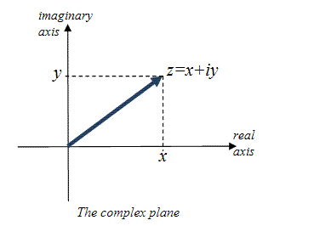
Source: helpingwithmath.com
Operations
Cartesian
Addition
$$\left(a+bi\right)+\left(c+di\right)=\left(a+c\right)+i(b+d)$$
Subtraction
$$\left(a+bi\right)-\left(c+di\right)=\left(a-c\right)+i(b-d)$$
Adding and subtracting complex numbers is similar to combining like terms in algebra. You add the real parts together, and add the imaginary parts together. Geometrically, it is similar to the vector addition: $\left(a,b\right)+\left(c,d\right)=(a+c, b+d)$

Multiplication
$$\left(a+bi\right)\left(c+di\right)=\left(ac-bd\right)+i(ad+bc)$$
To multiply two complex numbers, we use FOIL method (First, Outer, Inner, Last)
$$\left(a+bi\right)\left(c+di\right)=ac+adi+bci+bdi^{2}$$
which can be simplified as above equation.

Division
$$\frac{a+bi}{c+di}=\frac{(a+bi)(c-di)}{(c+di)(c-di)}=\frac{ac+bd}{c^{2}+d^{2}}+i\frac{bc-ad}{c^{2}+d^{2}}$$
We never leave an imaginary number $i$ in the denominator. Therefore, to eliminate $i$ from the denominator, we multiply both numerator and denominator by the conjugate of the denominator. Therefore, the denominator can become $c^{2}+d^{2}$ and allows us to separate the fraction into real and imaginary parts.

Trigonometric Form
Modulus$(r)$ and Argument$(θ)$
$$r=\left|z\right|=\sqrt{a^{2}+b^{2}}$$
$$\tan{θ}=\frac{b}{a}$$
Modulus is the straight-line distance from the origin to the point $(a,b)$. By the Pythagorean Theorem, $r=\sqrt{a^{2}+b^{2}}$ and $r≥0$.
Property of Modulus
$$\left|z_{1}\right|+\left|z_{2}\right|≥\left|z_{1}+z_{2}\right|$$
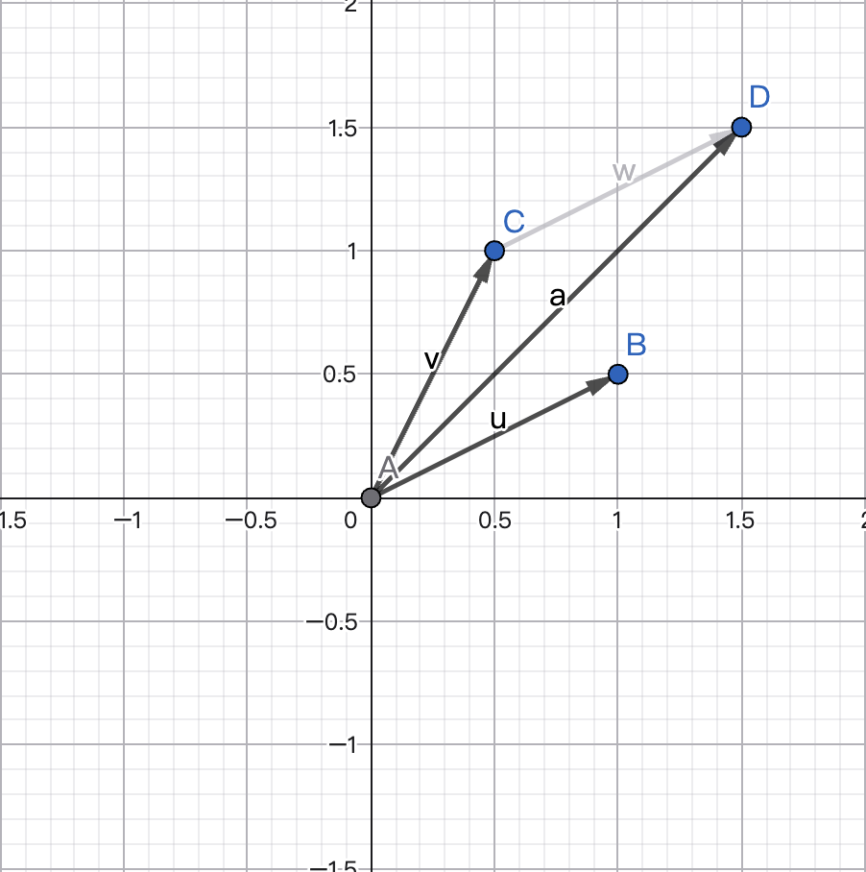
Let $\left|z_{1}\right|$to be vector u, and $\left|z_{2}\right|$to be vector v. Add $\left|z_{1}\right|$ and $\left|z_{2}\right|$connect the starting point to the end point. You can get $\left|z_{1}+z_{2}\right|$ which is vector a by the addition property of vectors. Now $\left|z_{1}\right|, \left|z_{2}\right|$ and $\left|z_{1}+z_{2}\right|$ form a triangle, in any triangle the sum of two sides is always larger or equal to the hypotenuse. Therefore, $\left|z_{1}\right|+\left|z_{2}\right|≥\left|z_{1}+z_{2}\right|$

$$\left|\left|z_{1}\right|-\left|z_{2}\right|\right|≤\left|z_{1}-z_{2}\right|$$
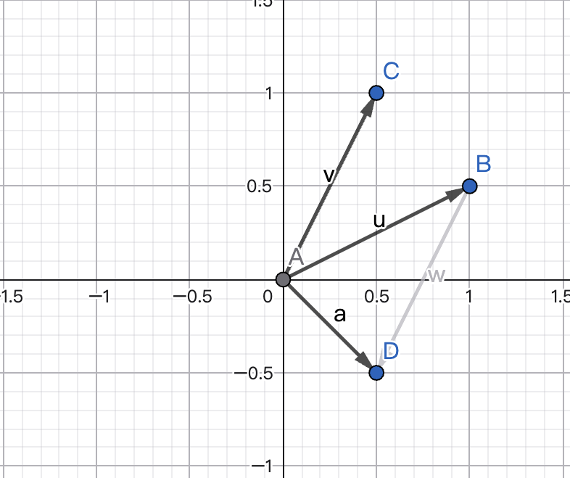
Let $\left|z_{1}\right|$to be vector u, and $\left|z_{2}\right|$to be vector v. Subtract $\left|z_{1}\right|$ by $\left|z_{2}\right|$connect the starting point to the end point. You can get $\left|z_{1}-z_{2}\right|$ which is vector a by the subtraction property of vectors. The difference in lengths of any two sides of a triangle must be less than or equal to the length of the third side. Therefore, $\left|\left|z_{1}\right|-\left|z_{2}\right|\right|≤\left|z_{1}-z_{2}\right|$

Argument is the direction angle measured counterclockwise from the positive real axis. By trigonometry, we can get $\tan{θ}=\frac{b}{a}$.
However, to calculate $θ$, there exists one case for each quadrant.
$$θ=\tan^{-1}\left|\frac{b}{a}\right|$$
This equation will only give a reference angle. You need to look at which quadrant $\left(a,b\right)$ is in.
Quadrant I: $θ=α$
Quadrant II: $θ=π-α$
Quadrant III: $θ=π+α$
Quadrant IV: $θ=2π-α$
Trigonometric form and polar coordinates
$$z=r\left(\cos{θ}+\sin{θ}\right)=rcisθ$$
Because writing $\cos{θ}+i\sin{θ}$ repeatedly is tedious, mathematicians simply use $cisθ$ to represent it.
Polar coordinates
$$x=r\cos{θ}$$
$$y=r\sin{θ}$$

Multiplication
$$z_{1}⋅z_{2}=r_{1}r_{2}\left(cos\left(θ_{1}+θ_{2}\right)+isin\left(θ_{1}+θ_{2}\right)\right.$$

The rule for multiplication is to multiply the length first, ${r=r}_{1}r_{2}$. Then add the angles together, ${θ=θ}_{1}+θ_{2}$. On the complex plane, it means stretching by factor $r_{2}$ and rotating counterclockwise by angle $θ_{2}$.
Division

$$\frac{z_{1}}{z_{2}}=\frac{r_{1}}{r_{2}}\left(cos\left(θ_{1}-θ_{2}\right)+isin\left(θ_{1}-θ_{2}\right)\right)$$
Division works exactly oppositive from multiplication.
First, divide the length $r=\frac{r_{1}}{r_{2}}$. Then subtract the angle, ${θ=θ}_{1}-θ_{2}$. On the complex plane, this means stretching by a factor of $\frac{1}{r_{2}}$ and rotating clockwise by $θ_{2}$.

De Moivre’s Theorem
The formula
De Moivre states that for any real number x and integer n
$${(\cos{x}+i\sin{x)}}^{n}=\cos{nx}+i\sin{nx}$$
De Moivre’s theorem is an extension of multiplication. It can be represented as two complex number multiply together.
$$(\cos{x}+i\sin{x)}(\cos{x}+i\sin{x)}=\cos\left(x+x\right)+i\sin\left(x+x\right)=\cos{2x}+\sin{2x}$$
If you do this for n times, you are adding the angle $x$ for n times. Therefore, raising the expression to $n$ power is simply multiplying the angle by $n$.

Powers
$$z^{n}={\left[r\left(cosθ+isinθ\right)\right]}^{n}=r^{n}\left(cos\left(nθ\right)+isin\left(nθ\right)\right)$$
Similar to the original form, you simply need to raise the magnitude to the $n$-th power as well which is $r^{n}$.

Roots
$$z_{k}=r^{\frac{1}{n}}\left(cos\left(\frac{θ+2πk}{n}\right)+isin\left(\frac{θ+2πk}{n}\right)\right), k=0,1,2….,n-1$$
According to fundamental algebra, any non-zero number has exactly $n$ distinct $n$-th roots. For instance, what is $\sqrt[3]{8}$, you will answer 2. But 2 is only one root of it, the other two are complex number. The root is a reverse of multiplication. $z^{n}=r$ and $z=\sqrt[n]{r}$. For argument, we use $n$ to multiply the angle in multiplication. Here, we do it inversely by dividing $n$ to the angle, $∅=\frac{θ}{n}$. But this can only give out one angle. We need to add $2πk$ on it. Knowing that adding a full rotation of $2π/360°$ will lands at the same spot, there will exist different angle when you divided by $n$.
Here is a quick example:
Suppose $n=3$ and $θ=0°$
First root ($k=0)$
$$\frac{0°}{3}=0°$$
Second root ($k=1)$
$$\frac{0°+360°}{3}=120°$$
Third root ($k=2)$
$$\frac{0°+720°}{3}=240°$$
And what if we keep going?
Fourth root ($k=3)$
$$\frac{0°+1080°}{3}=360°=0°$$
This is because the number of k is equal to n. There will simply be adding $360°$ to the original angle which is the exact same angle. That’s why we only need $k=0,1,2….,n-1$.

